**AKS UNIVERSITY SATNA**

**Institute Management Site**

# (Major Project)

A Project Report Submitted

In Partial Fulfilment of the Requirements for the Degree of

# BACHELOR OF

**COMPUTER APPLICATION**

**by**

## Rambabu

### (B1992R10400001)

**Under the Supervision of Mr. Hari Mohan Mishra** Assistant Professor



**Session: 2021-22**

**Department of Computer Science & Engineering**

AKS University, Satna

(Madhya Pradesh)

### Declaration

#### I hereby declare that the work which is being presented in the report, entitled “Institute Management Site” in partial fulfilment for the award of Degree of Bachelor of

**Computer Applications (BCA), submitted to the Department of Computer Science & Engineering, AKS University, Satna (MP).**

I have not submitted the matter presented in this report anywhere for any other Degree.

Rambabu (B1992R10400001)

Bachelor of Computer Applications (**BCA**)

### Certificate

This is to certify that

#### Rambabu (B1992R10400001)

Worked on the project **‘Institute Management Site’** from Feb 2021 to May 2021 and has successfully completed the major project, in order to partially fulfil the requirements for the award of the degree of Bachelor of Computer Applications (**BCA**) under my supervision and guidance.

**External Examiner Head of the Department**

**Internal Examiner Project Guide**

### ACKNOWLEDGEMENT

The satisfaction that accompanies the successful completion of any task would be incomplete without the mention of people whose ceaseless cooperation made it possible, whose constant guidance and encouragement crown all efforts with success.

**We are grateful to our project guide Mr. Hari Mohan Mishra and Prof. Akhilesh A. Waoo the Head of Department of Computer Science and Engineering and Information Technology, AKS University Satna (M.P), for their guidance, inspiration and constructive suggestions that helped us in the preparation of this project. They were always there guiding and correcting us with attention and care. They took immense pain going through the project and also the documentation and made the necessary**

**corrections as and when required.**

We would also take this opportunity to thank our Institution and other faculty members without whom this project would have been a distant reality.

**Table of content**

**Chapters**

1. Introduction
   1. Objective
   2. Motivation
   3. Advantages
   4. Existing Implementation
2. Hardware/Software requirements
   1. Hardware requirement
   2. Software requirement
   3. Knowledge Required
3. Front End - Back End Tool and Languages
   1. Front End Tool
   2. Back End Tool
   3. Back End Language
4. Source code
   1. Index page code
   2. Admission form code
   3. Admission form CSS code
5. Design and Framework
   1. Block diagram
   2. Flow chart
6. Testing
7. Application and scope
   1. Applications
   2. Scope
8. Getting Started
9. Future Enhancement
10. Conclusion
11. References
12. Annexure:
    * 1. Plagiarism Report
      2. PPT Handouts (6 PPT in One Page)
13. CD with Documents, Tools, Report and PPT

## 1. Introduction

My project title is Institute Management Site. I have tried my best to make the complicated process of Institute Management Site as simple as possible using Structured & Modular technique & Menu oriented interface. I have tried to design the Project in such a way that students may not have any difficulty in using this package & further expansion is possible without much effort. Even though I cannot claim that this work to be entirely exhaustive, the main purpose of my exercise is to perform each Employee’s activity in a computerized way rather than manually which is time consuming.

I am confident that this software package can be readily used by non-programming personnel avoiding human handled chances of

error. This project is used by two types of students

I. Online admitted Students. ii. Offline admitted students (Management of the Institute).

Online students can see the required articles or news

Administrators can maintain daily updates in the Institute records. Administrator must be an authorized student. He can further change the password. There is the facility for password recovery, logout etc.

The main aim of the entire activity is to automate the process of day-to-day activities of Institute like Class activities, Admission of a New Student, assign a Class according to Student’s demand, checkout of a computer and releasing the Class and finally compute the bill etc.

The limited time and resources have restricted us to incorporate, in this project, only the main activities that are performed in an Institute Management Site, but utmost care has been taken to make the system efficient and student friendly.

“Institute Management Site” has been designed to computerized the following functions that are performed by the system:

* Online Admission system
* Student login system
* Faculty login system
* Class Detail Functions
* Opening a New batch Class Details
* Modification to Class assigned
* Student Detail Functions
* Admission of New Student
* Class assigning related to Student’s needs.
* Statement of Student Details
* Check-in Student
* Check-out Student
* Total number of Students in the Institute
* Individual Student Report

### 1.1 Objective

During the past several decades personnel function has been transformed from a relatively obscure record keeping staff to central and top-level management function. There are many factors that have influenced this transformation like technological advances, professionalism, and general recognition of human beings as the most important resources.

□ A computer-based management system is designed to handle all the primary information required to calculate monthly statements. Separate database is maintained to handle all the

details required for the correct statement calculation and generation.

□ This project intends to introduce more student friendliness in the various activities such as record updating, maintenance, and searching.

□ The searching of records has been made quite simple as all the details of the student can be obtained by simply keying in the identification of that Student.

□ Similarly, record maintenance and updating can also be accomplished by using the identification of the student with all the details being automatically generated. These details are also being promptly automatically updated in the master file thus keeping the record absolutely up-to-date.

□ The entire information has been maintained in the database or Files and whoever wants to retrieve can’t retrieve, only authorization students can retrieve the necessary information which can easily be accessible from the file.

The main objective of the entire activity is to automate the process of day to day.

Activities of Institute like:

* Online Admission system
* Student login system
* Faculty login system
* Class Detail Functions
* Opening a New batch Class Details
* Modification to Class assigned
* Student Detail Functions
* Admission of New Student
* Class assigning related to Student’s needs.
* Statement of Student Details
* Check-in Student
* Check-out Student
* Total number of Students in the Institute

### Individual Student Report

### 1.2 Motivation

The main motivation or purpose of this vision document is to list the requirements of the Institute Management Site Project. This document also helps us to collect and analyse the ideas gathered for the project. This vision document will be subject to change, if more requirements are added to the project. This document is mainly prepared to set the stage for the design phase of the project. The document being prepared is the first version of the vision document for the Institute management project.

### 1.3 Advantages

I have designed the given proposed system using Web Technologies to automate the process of Institutes. This project is useful for the authorities which keep track of all the students registered in a particular state. The authority can add Institute courses, Class details, availability of seats, admission etc.

* The advantages of Institute management site are that you can take admission without visiting to the institute. Our legendary team service extends to the web
* One advantage of taking admission with the Institute directly is the use of the Institute's full discount policy as well as not needing a deposit in most situations.

The most important advantage of online Institute management site is convenience, you can take your Class by simply sitting at home. The Internet helps you to browse through the Institutes around the world and compare the facilities and rates easily.

The following steps that give the detailed information of the need of proposed system are:

**Performance:** During the past several decades, the records are supposed to be manually handled for all activities. The manual handling of the record is time consuming and highly prone to error.

To improve the performance of the Institute Management Site, the computerized system is to be undertaken. This project is fully computerized and student friendly even that any of the members can see the report and status of the company.

**Efficiency:** The basic need of this website is efficiency. The website should be efficient so that whenever a new student submits his/her details the website is updated automatically. This record will be useful for other students instantly.

**Control:** The complete control of the project is under the hands of an an authorized person who has the password to access this project and illegal access is not supposed to deal with. All the control is under the administrator and the other members have the rights to just see the records not to change any transaction or entry.

**Security:** Security is the main criteria for the proposed system. Since illegal access may corrupt the database. So security has to be given in this project.

**PROJECT CATEGORY**

This Project is coupled with material on how to use the various tool sub sets available in Web Technologies.

### 1.4 Existing implementations

The INSTITUTE MANAGEMENT SYSTEM consists of 2 modules

and 5 categories. The categories are as follows:

1. Online admission
2. Student detail module

The modules are

Administrator Student

**Admin Module:**

The Functionalities of the Administrator is:

1. The administrator should login into the system with his/her password and student name.
2. If the student name and password is validated then he can gain access to the system.
3. View the student datail can update and delete the detail.
4. Post the special offers, add a new Institute of the Institutes list.
5. Insert /View the Availability and Price.
6. Post the links. Adding the links to the Institutes and as well view the links.
7. Blocks the student view the status of the students.
8. Restrict the student to the see the more information without login.

**The Administrator can do the following actions:**

1. Login
2. Change Password
3. Admin Functionalities
   1. View Institutes
   2. Add students
   3. Post Special Offers
   4. Edit / Delete students
   5. Upload Institute and student mages.
   6. Logout

**Student Module:**

The Functionalities of the Student is:

1. A new Student can register with the application by entering his appropriate details.
2. The Student should login into the system with his/her password and student name.
3. If the student name and password is validated then he can gain access to the system.
4. The Student can change his password, To change the password, it should ask for the old password, new password and confirm new password
5. View the Categories.

**The Student can do the following actions:**

1. Register
2. Login
3. Change Password
4. Student Functionalities
   1. Online admission
   2. Online classes
   3. Personal information
5. Logout

**Student Analysis:**

Student analysis is the process of identifying the different categories of students to the application,

their hierarchies and their functionalities.

**Home Page:** Like all the other Institute websites available online, the student can access the student home page of the Institute Reservation System , after he logs into the system. Here, he can look up information regarding flights.

**Login and Register**: The Institute Management also comes with the Student registration details page, where the Student can enter his details and register.

## 2. Hardware/Software requirements

**2.1 Hardware Requirement**

* CPU
* Monitor/Projector
* Keyboard
* Mouse
* 512MB RAM (Minimum)
* Minimum HDD/SDD on the Basis of your OS
* Any Device with Internet Connection with browser to access website.

**2.2 Software Requirement**

* Browser
* Any Operating System

**2.3 Knowledge Required**

* Students should have Basic knowledge of using internet connection and browsing any website or interacting with any online web based application.

## 3. Front End - Back End Tool and Languages

**3.1 Front End Tool** - HTML, CSS, JavaScript, jQuery, Bootstrap, PHP.

**3.2 Back End Tool** - Linux Server, MYSQL.

**3.3 Back End Language** - PHP.

**Source code**

Index page:-

<?php

include 'header.php';

?>

<!DOCTYPE html>

<html>

<head>

<meta charset="UTF-8">

<title>Mathur institute of computer sciience</title>

<link rel="stylesheet" href="css/index.css"/>

<meta http-equiv="content-type" content="text/html; charset=utf-8" />

<meta name="description" content="MICS" />

<link rel="stylesheet" type="text/css" href="engine1/style.css" />

<script type="text/javascript" src="engine1/jquery.js"></script>

</head>

<body style="margin:auto">

<br>

<!-- Start slider BODY section --> <!-- add to the <body> of your page -->

<div id="wowslider-container1">

<div class="ws_images"><ul>

<li><img src="data1/images/6.jpg" alt="6" title="6" id="wows1_0"/></li>

<li><img src="data1/images/3.jpg" alt="3" title="3" id="wows1_1"/></li>

<li><img src="data1/images/4.jpg" alt="4" title="4" id="wows1_2"/></li>

<li><img src="data1/images/2.jpg" alt="2" title="2" id="wows1_3"/></li>

<li><img src="data1/images/1.jpg" alt="slider html" title="1" id="wows1_4"/></li>

<li><img src="data1/images/5.jpg" alt="5" title="5" id="wows1_5"/></li>

</ul></div>

<div class="ws_bullets"><div>

<a href="#" title="6"><span><img src="data1/tooltips/6.jpg" alt="6"/>1</span></a>

<a href="#" title="3"><span><img src="data1/tooltips/3.jpg" alt="3"/>2</span></a>

<a href="#" title="4"><span><img src="data1/tooltips/4.jpg" alt="4"/>3</span></a>

<a href="#" title="2"><span><img src="data1/tooltips/2.jpg" alt="2"/>4</span></a>

<a href="#" title="1"><span><img src="data1/tooltips/1.jpg" alt="1"/>5</span></a>

<a href="#" title="5"><span><img src="data1/tooltips/5.jpg" alt="5"/>6</span></a>

</div></div>

<div class="ws_shadow"></div>

</div>

<script type="text/javascript" src="engine1/wowslider.js"></script>

<script type="text/javascript" src="engine1/script.js"></script>

</html>

<?php

include 'footer.php';

?>

**Online Admission form source code:-**

<?php

include 'header.php';

include 'connection.php';

?>

<!Doctype HTML>

<html>

<head>

<title> Apply Online</title>

<link rel="stylesheet" href="css/register.css"/>

</head>

<body>

<div class="main">

<div class="register">

<h2>Apply Online</h2>

<form id="register" method="post">

<label>First Name: </label>

&nbsp;&nbsp;&nbsp;&nbsp;&nbsp;&nbsp;&nbsp;

<input type="text" name="fname"id="name"placeholder="Enter your First name">

<br><br>

<label> Last Name:</label>

&nbsp;&nbsp;&nbsp;&nbsp;&nbsp;&nbsp;&nbsp;

<input type ="text" name="lname"id="name"placeholder="Enter your Last name">

<br><br>

<label>Father's name: </label>&nbsp;&nbsp;

<input type="text" id="name" name="fathername"placeholder="Enter your father name">

<br><br>

<label>Mother's name: </label>&ensp;

<input type="text" id="name" name="mothername"placeholder="Enter your mother name">

<br><br>

<label> DOB: </label>&ensp;&ensp;&ensp;&ensp;&ensp;&ensp;&ensp;&ensp;&nbsp;&nbsp;

<input type="date" name="dob" id="name"placeholder="How old are you?">

<br>

<label>Gender</label>&ensp;&ensp;&ensp;&ensp;&ensp;&ensp;&ensp;&nbsp;

<input type="radio"name="gender"id="male">

<span id="male">Male</span>&ensp;&ensp;&nbsp;

<input type="radio"name="gender" id="female">

<span id="female">Female</span>

<br><br>

<label> Nationality:</label>&ensp;&ensp;&ensp;&ensp;&ensp;

<select name="nationality"id="name">

<option> <--Select--></option>

<option> Indian</option>

<option> Other...</option>

</select>

<br><br>

<label> State:</label>&ensp;&ensp;&ensp;&ensp;&ensp;&ensp;&ensp;&ensp;&ensp;

<select name="state"id="name">

<option> <--Select--></option>

<option>Andhra Pradesh </option>

<option>Arunachal Pradesh </option>

<option>Assam </option>

<option>Bihar </option>

<option>Chhattisgarh </option>

<option>Goa </option>

<option>Gujarat </option>

<option>Haryana </option>

<option>Himachal Pradesh </option>

<option>Jammu and Kashmir </option>

<option>Jharkhand </option>

<option>Karnataka </option>

<option>Kerala </option>

<option>Madhya Pradesh </option>

<option>Maharashtra </option>

<option>Manipur </option>

<option>Meghalaya </option>

<option>Mizoram </option>

<option>Nagaland </option>

<option>Odisha </option>

<option>Punjab </option>

<option>Rajasthan </option>

<option>Sikkim </option>

<option>Tamil Nadu </option>

<option>Telangana </option>

<option>Tripura </option>

<option>Uttar Pradesh </option>

<option>Uttarakhand </option>

<option>West Bengal </option>

</select>

<br><br>

<label>Contact no.: </label>&ensp;&ensp;&ensp;&nbsp;

<input type="number" name="contact"id="name"placeholder="Enter your Valid Contact Number">

<br><br>

<label>E-mail:</label>&ensp;&ensp;&ensp;&ensp;&ensp;&ensp;&ensp;&ensp;

<input type ="email" name="email"id="name"placeholder="Enter your valid E-mail">

<br><br>

<label>Highest qualification: </label>

<select name="qualification"id="name">

<option> <--Select--></option>

<option>Primary Education</option>

<option> Middle Ecucation</option>

<option>High School Education</option>

<option>Intermediate or secondary education</option>

<option>Graduation</option>

<option>Post Graduation</option>

<option>Others...</option>

</select>

<br><br>

<label>Course: </label>&ensp;&ensp;&ensp;&ensp;&ensp;&ensp;&ensp;

<select name="course"id="name"placeholder="Select your Course">

<option> <--Select--></option>

<option>ADCA</option>

<option>DCA</option>

<option>CCC</option>

<option>Tally</option>

<option>MS Office Tools</option>

<option>Photoshop</option>

<option>BCC</option>

<option>Hindi English Typing</option>

<option>Video Editing</option>

<option>HTML & CSS</option>

<option>C, C++ Programmming</option>

<option>Java & Python</option>

<option>Web Designing</option>

<option> O level</option>

<option></option>

<option>Banking</option>

<option>Internet</option>

<option>CSC work</option>

</select>

<br><br>

<label>Address: </label>&ensp;&ensp;&ensp;&ensp;&ensp;&ensp;

<textarea name="address"id="name"placeholder=""></textarea>

<br><br>

<label>Photo: </label>&ensp;&ensp;&ensp;&ensp;&ensp;&ensp;&ensp;&ensp;

<input type="file" name="photo"id="photo">

<br><br>

&ensp;&ensp;&ensp;&ensp;&ensp;&ensp;&ensp;&ensp;&ensp;&ensp;&ensp;&ensp;

<input type="reset" name="reset"id="submit">

<input type="submit" name="submit" id="submit" class="reset">

</form>

</div>

</div>

<?php

if(isset($_POST['submit']))

{

$conn = new mysqli($servername, $username, $password,"my_institutedb");

$fname=$_POST['fname'];

$lname=$_POST['lname'];

$fathername=$_POST['fathername'];

$mothername=$_POST['mothername'];

$dob=$_POST['dob'];

$gender=$_POST['gender'];

$nationality=$_POST['nationality'];

$state=$_POST['state'];

$contact=$_POST['contact'];

$email=$_POST['email'];

$qualification=$_POST['qualification'];

$course=$_POST['course'];

$address=$_POST['address'];

$photo=$_POST['photo'];

mysqli_query($conn,"insert into admission values('$fname','$lname','$fathername','$mothername','$dob','$gender','$nationality','$state','$contact','$email','$qualification','$course','$address','$photo')");

echo"Saved";

}

include 'footer.php';

?>

</body>

</html>

**Admission form CSS source code:**

body

{

background-image: url(../image/login.jpg);

background-size: cover;

background-repeat: repeat-y;

box-sizing:border-box;

font-family:sans-serif;

}

div.main{

width: 600px;

margin:-70px auto 0px auto;

}

h2{

text-align: center;

padding: 20px 0px;

border-bottom: 1px solid silver;

font-family: blacksword;

font-size: 50px;

}

div.register{

background-color: rgba(0,0,0,0.5);

width:100%;

font-size: 18px;

border-radius:10px;

border:1px solid rgba(255,255,255,0.3);

box-shadow: 2px,2px,15px rgba(0,0,0,0.3);

color:#fff;

}

form#register

{

margin: 40px;

}

label

{

font-family: sans-serif;

font-size: 16px;

transition: .5s;

}

input#name{

width: 300px;

border: 1px solid #ddd;

border-radius: 3px;

outline: 0;

padding: 5px;

background-color: #fff;

box-shadow: inset 1px 1px 5px rgba(0,0,0,0.3);

}

input#submit{

width: 150px;

height: 30px;

border: 1px solid;

background: #2691d9;

border-radius: 10px;

font-size: 16px;

color: #e9f4fb;

font-weight: 500;

cursor: pointer;

outline: none;

}

input#submit:hover{

background-color: green;

box-shadow: 0 5px 15px rgba(255,255,255,0.5);

font-size: 18px;

}

**2.2.1 HTML-**

HTML or Hyper Text Mark-up Language is the standard mark-up language used to create web pages. HTML is written in the form of HTML elements consisting of tags enclosed in angle brackets. HTML tags most commonly come in pairs like and, although some tags the structure of a website semantically along with presentation, making represent empty elements and so are unpaired. The first tag in a pair is the start tag, and the second tag is the end tag (they are also called opening tags and closing tags). A web browser can read HTML files and compose them into visible or audible web pages. The browser does not display the HTML tags, but uses them to interpret the content of the page. HTML describes it a mark-up language rather than a programming language.

**2.2.2CSS-**

* **CSS** stands for **C**ascading **S**tyle **S**heets
* CSS describes **how HTML elements are to be displayed on screen, paper, or in other media**
* CSS **saves a lot of work**. It can control the layout of multiple web pages all at once
* External stylesheets are stored in **CSS files**

CSS is used to define styles for your web pages, including the design, layout and variations in display for different devices and screen sizes.

**2.2.3Bootstrap-**

* Bootstrap is a free front-end framework for faster and easier web development
* Bootstrap includes HTML and CSS based design templates for typography, forms, buttons, tables, navigation, modals, image carousels and many other, as well as optional JavaScript plugins.
* Bootstrap also gives you the ability to easily create responsive designs.
* Bootstrap was developed by Mark Otto and Jacob Thornton at Twitter, and released as an open source product in August 2011 on GitHub.
* **In June 2014 Bootstrap was the No.1 project on GitHub**

**2.2.4JavaScript-**

JavaScript is one of the **3 languages** all web developers **must** learn:

   1. **HTML** to define the content of web pages

   2. **CSS** to specify the layout of web pages

   3. **JavaScript** to program the behavior of web pages

Web pages are not the only place where JavaScript is used. Many desktop and server programs use JavaScript. Node.js is the best known. Some databases, like MongoDB and CouchDB, also use JavaScript as their programming language.

JavaScript is a very powerful **client-side scripting language**. JavaScript is used mainly for enhancing the interaction of a user with the webpage. In other words, you can make your webpage more lively and interactive, with the help of JavaScript.

**2.3 INTRODUCTION OF MYSQL (Back End)**

MySQL is the most popular Open Source Relational SQL Database Management System. MySQL is one of the best RDBMS being used for developing various web-based software applications. MySQL is developed, marketed and supported by MySQL AB, which is a Swedish company.

**2.3.1 What is a Database?**

A database is a separate application that stores a collection of data. Each database has one or more distinct APIs for creating, accessing, managing, searching and replicating the data it holds.

Other kinds of data stores can also be used, such as files on the file system or large hash tables in memory but data fetching and writing would not be so fast and easy with those type of systems.

Nowadays, we use relational database management systems (RDBMS) to store and manage huge volume of data. This is called relational database because all the data is stored into different tables and relations are established using primary keys or other keys known as **Foreign Keys**.

**2.3.2 MySQL Database**

MySQL is a fast, easy-to-use RDBMS being used for many small and big businesses. MySQL is developed, marketed and supported by MySQL AB, which is a Swedish company. MySQL is becoming so popular because of many good reasons −

* MySQL is released under an open-source license. So you have nothing to pay to use it.
* MySQL is a very powerful program in its own right. It handles a large subset of the functionality of the most expensive and powerful database packages.
* MySQL uses a standard form of the well-known SQL data language.
* MySQL works on many operating systems and with many languages including PHP, PERL, C, C++, JAVA, etc.
* MySQL works very quickly and works well even with large data sets.
* MySQL is very friendly to PHP, the most appreciated language for web development.
* MySQL supports large databases, up to 50 million rows or more in a table. The default file size limit for a table is 4GB, but you can increase this (if your operating system can handle it) to a theoretical limit of 8 million terabytes (TB).
* MySQL is customizable. The open-source GPL license allows programmers to modify the MySQL software to fit their own specific environments

**4. Design and Framework**

BEHAVIORAL DESCRIPTION

**Data Flow:**

**There are three types of DFD’s they are**

* 1. **Context Level DFD**
  2. **Top Level DFD and**
  3. **Detailed Level DFD**

**Context Level DFD:**

In the Context Level the whole system is shown as a single process.

* No data stores are shown.
* Inputs to the overall system are shown together with data sources (as External entities).
* Outputs from the overall system are shown together with their destinations (as External entities).

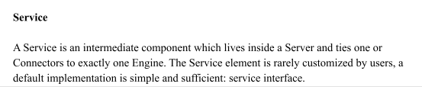

**DFD:**

**Activity Diagrams:**

* An activity diagram shows the flow from activity to activity. An activity is an ongoing non-

atomic execution within a state machine.

* Activities ultimately result in some action, which is made up of executable atomic computations that result in a change in state of the system or the return of a value.

Activity diagrams commonly contain

□ Activity states and action states

□ Transitions

□ Objects

* Like all other diagrams, activity diagrams may contain notes and constraints.

**Login Process**

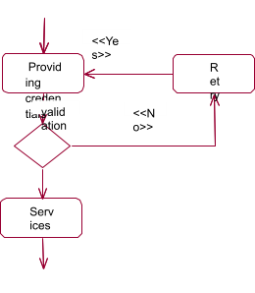

**Un Registration Process**

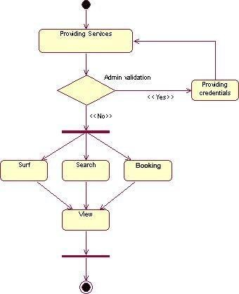

Registration process

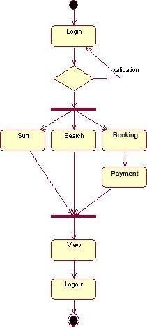

Administrator process

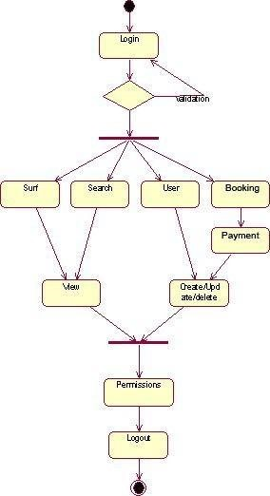

Component diagram

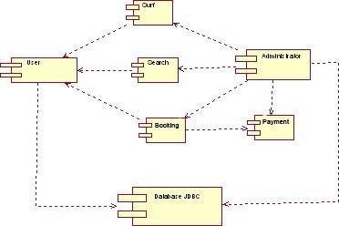

**Deployment Diagram**

* A deployment diagram is a diagram that shows the

configuration of run time processing nodes and the components that live on them.

* Graphically, a deployment diagram is a collection of vertices and arcs.

**Contents**

-Deployment diagram commonly contain the following things:

* + Nodes
  + Dependency and association relationships
* Like all other diagrams, deployment diagrams may contain notes and constraints.
* Deployment diagrams may also contain components, each of which must live on some node.
* Deployment diagrams may also contain packages or subsystems, both of which are used to group elements of your model into larger chunks

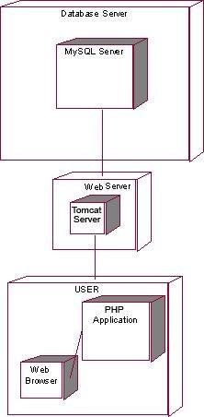

## 5. Testing

* **Testing Methodologies** o Black box Testing: o White box Testing. o Gray Box Testing.
* **Levels of Testing** o Unit Testing. o Module Testing. o Integration Testing. o System Testing.

o Student Acceptance Testing.

* **Types Of Testing** o Smoke Testing. o Sanitary Testing. o Regression Testing. o Re-Testing. o Static Testing. o Dynamic Testing. o Alpha-Testing. o Beta-Testing. o Monkey Testing. o Compatibility Testing. o Installation Testing. o Adhoc Testing. o Ext….
* **TCD (Test Case Documentation)**
* **STLC**
  + Test Planning.
  + Test Development. **o** Test Execution. **o** Result Analysis. **o** Bug-Tracing. **o** Reporting. **o** Microsoft Windows – Standards **o** Manual Testing **o** Automation Testing (Tools) **o** Win Runner. **o** Test Director

**Testing:**

* The process of executing a system with the intent of finding an error.
* Testing is defined as the process in which defects are identified, isolated, subjected for rectification and ensured that product is defect free in order to produce the quality product and hence Student satisfaction.
* Quality is defined as justification of the requirements **●** Defect is nothing but deviation from the requirements **●** Defect is nothing but a bug.
* Testing --- The presence of bugs
* Testing can demonstrate the presence of bugs, but not their absence **●** Debugging and Testing are not the same thing!
* Testing is a systematic attempt to break a program or the AUT
* Debugging is the art or method of uncovering why the script /program did not execute properly.

**Testing Methodologies:**

* **Black box Testing**: is the testing process in which tester can perform testing on an application without having any internal structural knowledge of application.

Usually Test Engineers are involved in the black box testing.

* **White box Testing**: is the testing process in which testers can perform testing on an application with internal structural knowledge.

Usually The Developers are involved in white box testing.

* **Gray Box Testing**: is the process in which the combination of

black box and white box techniques are used.

**Levels of Testing:**

**Test Planning:**

**1.**Test Plan is defined as a

strategic document which describes the procedure on how to perform various testing on the total application in the most efficient way.

* + 1. Objective of testing,
    2. Areas that need to be tested,
    3. Areas that should not be tested,
    4. Scheduling Resource Planning,

**7.** Areas to be automated, various testing tools use

**Test Development**:

**1.** Test case Development (check list)

**2.** Test Procedure preparation. (Description of the test cases)

**Test Execution**: **1.** Implementation of test cases. Observing the result.

**Result Analysis**:

**1.** Expected value: is nothing but expected behavior Of application.

**2.** Actual value: is nothing but actual behavior of the application

|  |  |
| --- | --- |
| **Bug Tracing:** | Collect all the failed cases, prepare documents. |
| **Reporting:** | Prepare document (status of the application) |

**Types Of Testing:**

* **Smoke Testing**: is the process of initial testing in which tester looks for the availability of all the functionality of the application in order to perform detailed testing on them. (Main check is for available forms)
* **Sanity Testing:** is a type of testing that is conducted on an application initially to check for the proper behavior of an application that is to check all the functionality are available before the detailed testing is conducted by them.
* **Regression Testing:** is one of the best and important testing. Regression testing is the process in which the functionality, which is already tested before, is once again tested whenever some new change is added in order to check whether the existing functionality remains the same.
* **Re-Testing:** is the process in which testing is performed on some functionality which is already tested before to make sure that the defects are reproducible and to rule out the environment's issues if at all any defects are there.
* **Static Testing:** is the testing, which is performed on an application when it has not been executed. ex: GUI, Document

Testing

* **Dynamic Testing:** is the testing which is performed on an

application when it is being executed. ex: Functional testing.

* **Alpha Testing:** it is a type of student acceptance testing, which is conducted on an application when it is just before

released to the Student.

* **Beta-Testing:** it is a type of UAT that is conducted on an application when it is released to the Student, when deployed into the real time environment and being accessed by the real time students.
* **Monkey Testing:** is the process in which abnormal operations, beyond capacity operations are done on the application to check the stability of it in spite of the students abnormal behavior.
* **Compatibility testing:** it is the testing process in which usually the products are tested on the environments with different combinations of databases (application servers, browsers…etc) In order to check how far the product is compatible with all these environment platform combinations.
* **Installation Testing:** it is the process of testing in which the tester tries to install or try to deploy the module into the corresponding environment by following the guidelines produced in the deployment document and checking whether the installation is successful or not.

**Adhoc Testing:** Adhoc Testing is the process of testing in which unlike the formal testing where in test case document is used, without that test case document testing can be done of an application, to cover that testing of the future which are not covered in that test case document. Also it is intended to perform GUI testing which may involve the cosmetic issues

**TCD (Test Case Document):**

**Test Case Document Contains**

* **Test Scope (or) Test objective**
* **Test Scenario**
* **Test Procedure**
* **Test case**

This is the sample test case document for the Academic details of student project:

**Test scope:**

* Test coverage is provided for the screen “ Academic status entry” form of a student module of

university management system application

● Areas of the application to be tested **Test Scenario:**

* When the office personals use this screen for the marks entry,

calculate the status details,

saving the information on student’s basis and quit the form.

**Test Procedure:**

* The procedure for testing this screen is planned in such a way that the data entry, status calculation

functionality, saving and quitting operations are tested in terms of Gui testing, Positive testing, Negative testing using the corresponding Gui test cases, Positive test cases, Negative test cases respectively

**Test Cases:**

**Template for Test Case**

**Guidelines for Test Cases**:

**1. GUI Test Cases:**

* Total no of features that need to be check
* Look & Feel
* Look for Default values if at all any (date & Time, if at all any require)
* Look for spell check

**Example for GUI Test Cases**

**Positive Test Cases**

* The positive flow of the functionality must be considered
* Valid inputs must be used for testing
* Must have the positive perception to verify whether the requirements are justified.

**Example for Positive Test cases:**

**3. Negative Test Cases:**

* Must have negative perception.
* Invalid inputs must be used for testing.

**Example for Negative Test cases**:

|  |  |  |  |  |
| --- | --- | --- | --- | --- |
| T.C.No | Description | Exp | Act | Result |
|  |  |  |  |  |
| T.C.  No | Description | Expected value | Actua l value | Res |
| 1 | Check for  all the features in the screen | The screen must  contain all the features |  |  |
| 2 | Check for the alignment of  the objects as per the validations | The alignment should be in proper way |  |  |
| T.C.  No | Description | Expected value | Actua l value | R |
| 1 | Check for the date Time  Auto Display | The date and time of the system must be displayed |  |  |
| 2 | Enter the valid Roll no into th | It should accept |  |  |
|  | student roll no field |  |  |  |
| T.C.  No | Description | Expected value | Actual value | Resu |
| 1 | Try to modify the information i date and time | Modification should not be allow |  |  |
| 2 | Enter invalid data in to the studen details form, click on  Save | It should not accept invali data, save should not allow |  |  |

# Student and student

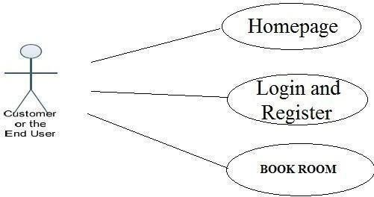

Some of the functions of the Institute Management, such as creating, maintaining and updating the database are available only to the administrator. The functions of the administrator, explained in detail are as follows:

## Administrator Activities

**Login:** The administrator has to login first in order to be able to make changes to the Institute Management, by adding, deleting or modifying the data in the Institute Management database.

**Add/Modify Student Information:** Daily the Institute Management will have many Students registering with the application and many of them unsubscribing. Only the administrator will have the sole rights to modify the database accordingly.

**Add/Modify Flight Information:** The Administrator also has the sole rights to add, delete or modify the studemt information. Sometimes any Class information has to be modified or if any new flights need to be added to the database, these operations are performed

by the administrator.

**administrator use case diagram**

## STUDENT CHARACTERISTICS

There are two kinds of students for institute Management. One is the Student and

the other is the administrator. The Students do not need to have any prior training to use the application. However, instructions for making Class reservations would be provided to them through application. The administrators would however need to be trained in order to use the application.

## CONSTRAINTS

In case of changes made to the database, the application should be able to show the updated information without much delay. The database for the project is designed to be of moderate size. The Institute Management Site will be designed in such a way that it can be run on Windows 8 and its older versions.

**SPECIFIC REQUIREMENTS**

## EXTERNAL INTERFACES

The different types of interfaces that we would come across while developing the Institute management application are as follows:

* Student Interface
* Hardware Interface
* Software Interface
* **STUDENT INTERFACE-**

There are two types of students for the Institute Management project. One is the student and the other is the administrator. Both

The student and administrator student interface

would be a graphical student interface. The graphical student interface for the student home page would be as follows:

**Home Page:**

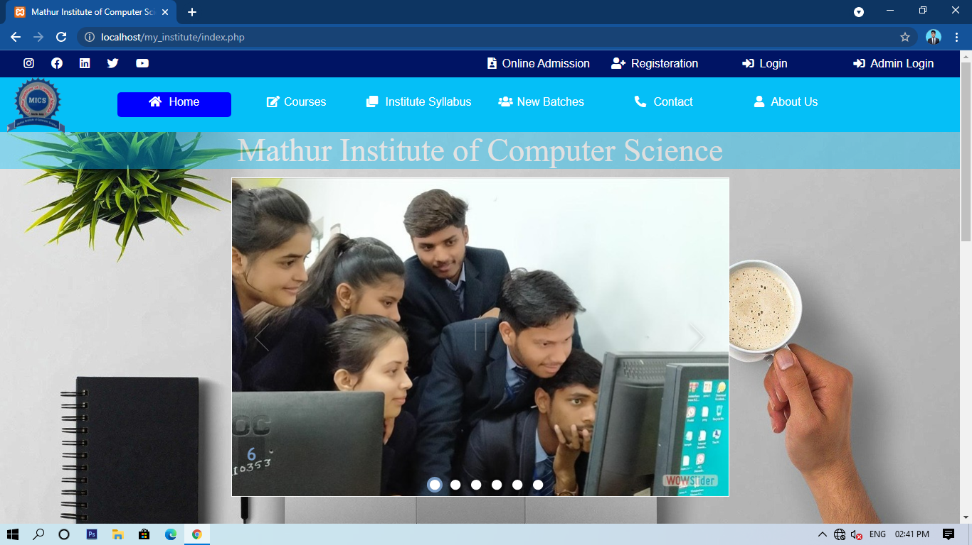

* **STUDENT INTERFACE-**

There are two types of students for the Institute Management project. One is the student and the other is the administrator. Both

The student and administrator student interface

would be a graphical student interface. The graphical student interface for the student home page would be as follows:

Home page contains a image slider where student and institute images are continuously scrolling . Student fill the admission form for the taking admission in institute as per date,

Anyone can see follow us social media by clicking on social icons.

In the home page many buttons are available. You can use the various services which provided by institute by clicking on the buttons

In the home page many courses are also available. Student can apply for any course according to their need.

**Admission Form:**

You can apply for any course clicking on courses menu, select your course for which course you want to apply.

After clicking on particular course button or online admission button, this apply online page will we display in front of you.

By filling this form you can apply for any course on institute.

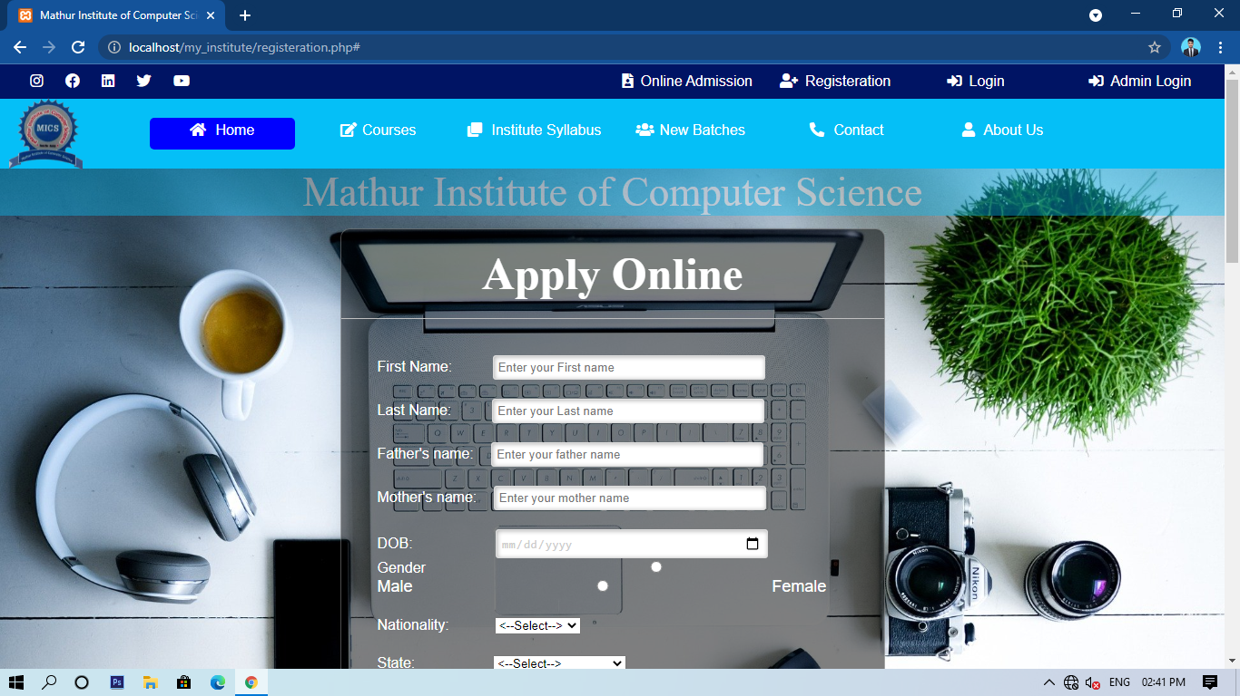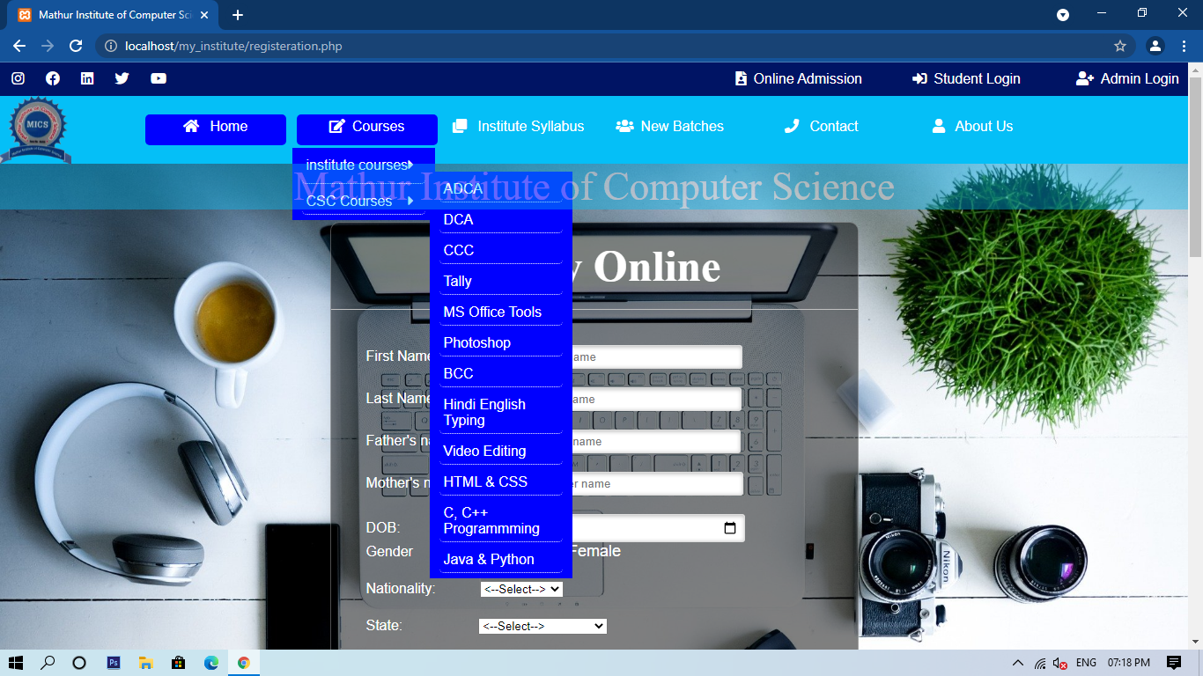

**Footer page:**

In the footer page you can read about us.

You can send us your email for newsletter.

Many links are available in footer like services, features, contacts, and about us, many social links are also available.

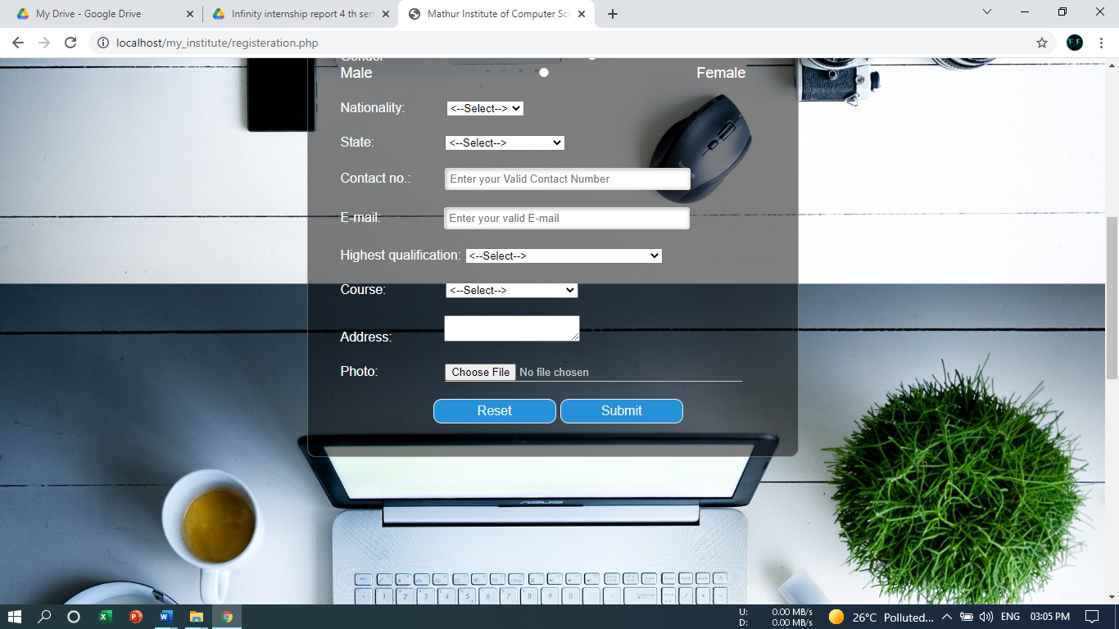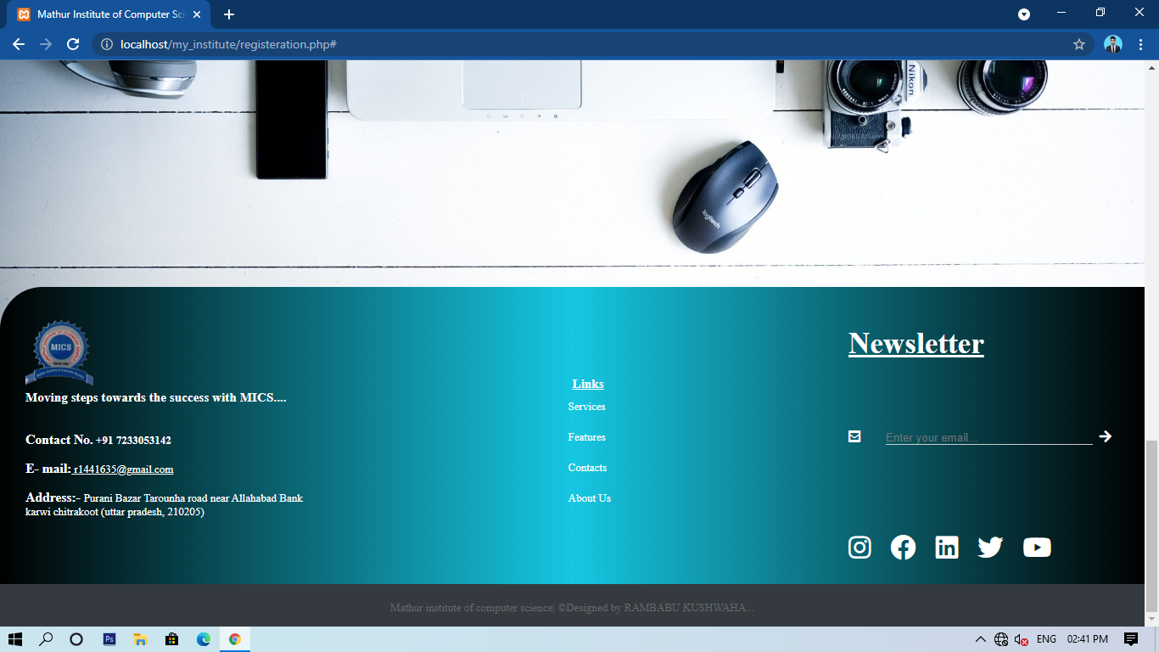

**Student Registration form:**

By filling out this form student can register itself.

And after register they will get an student ID and password.

By using that id and password they can login itself and use institute services**.**

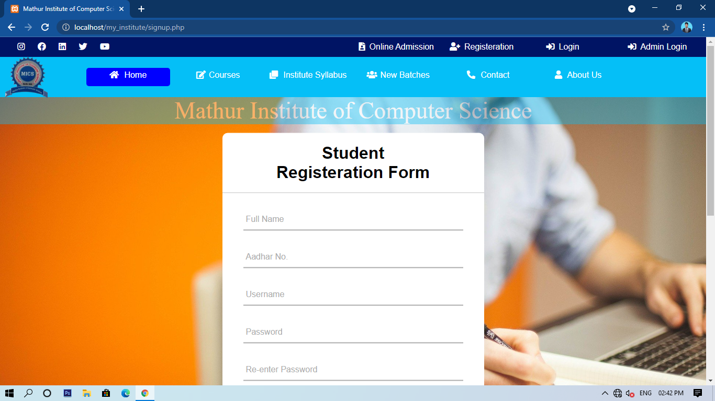

**Login Form:**

After registration student can login from here and they can see their profile.

If student have not any id password then by clicking on signup button they can register him/herself and they can get a student id and password,

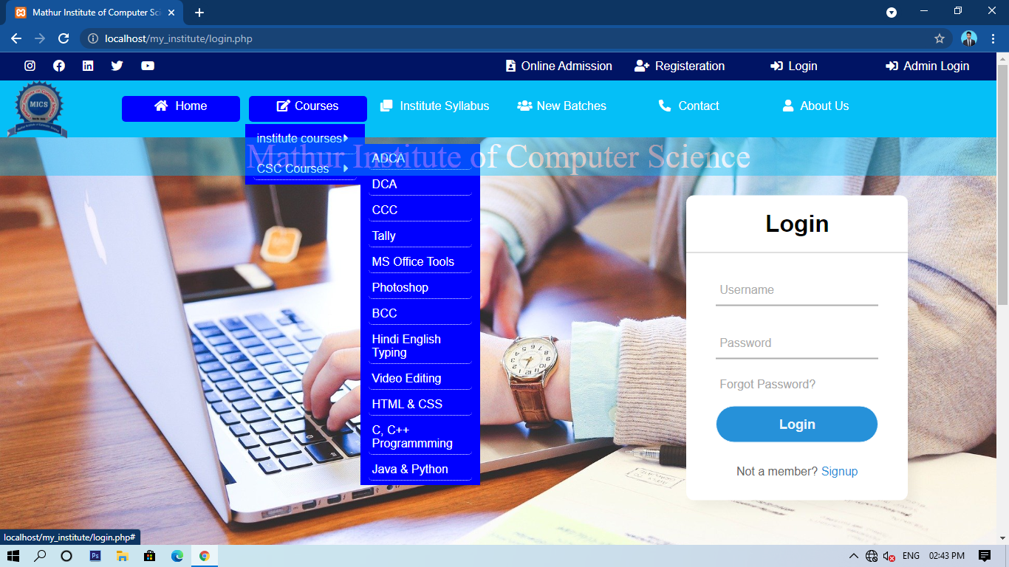

**Teacher/Faculty/admin Registration form:**

By filling out this form teacher can register itself.

And after register they will get an student ID and password.

By using that id and password they can login itself and manage institute services**.**

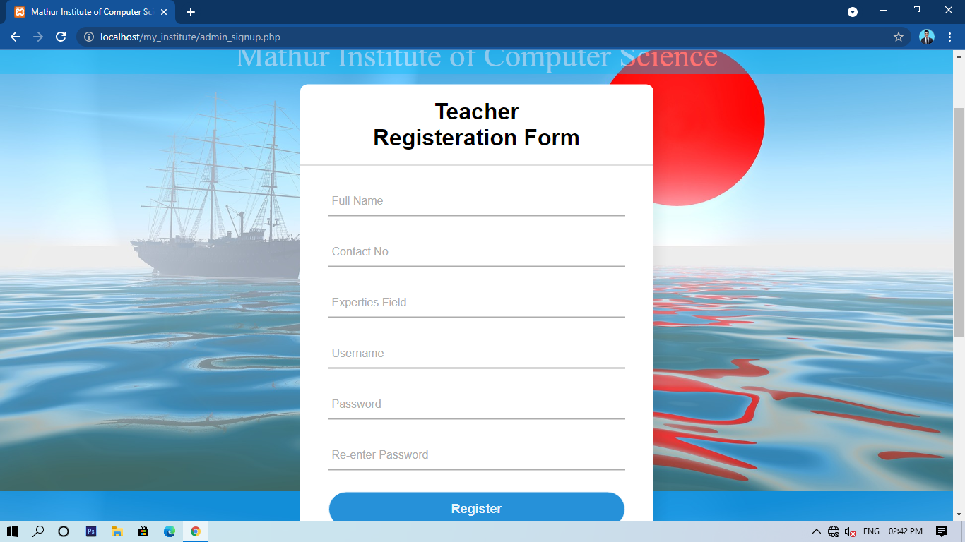

**Admin login page:**

After registration admin can login from here and they can see their profile.

If student have not any id password then by clicking on signup button they can register him/herself and they can get a student id and password,

During the registration which mobile number you will be provide, on that number an OTP will be send.

By entering that OTP you can verify yourself and do logged in yourself.

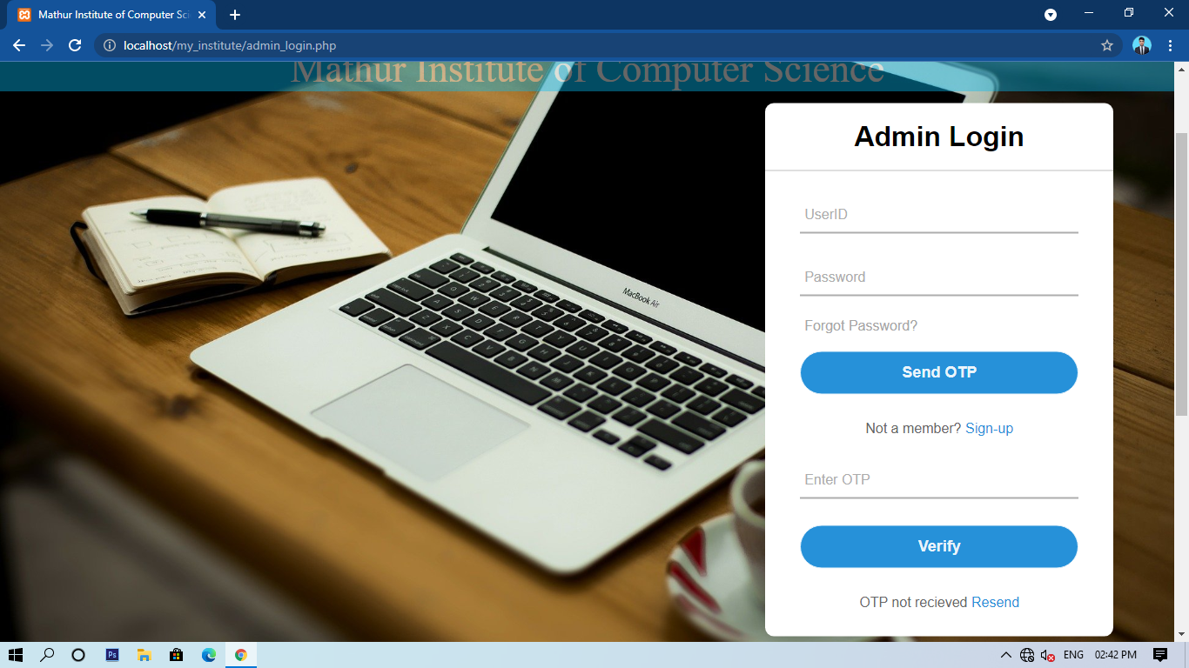

**Database Tables:**

These are the database tables where the data will be store.

There are some tables like, admin_signup, admission registration and etc…

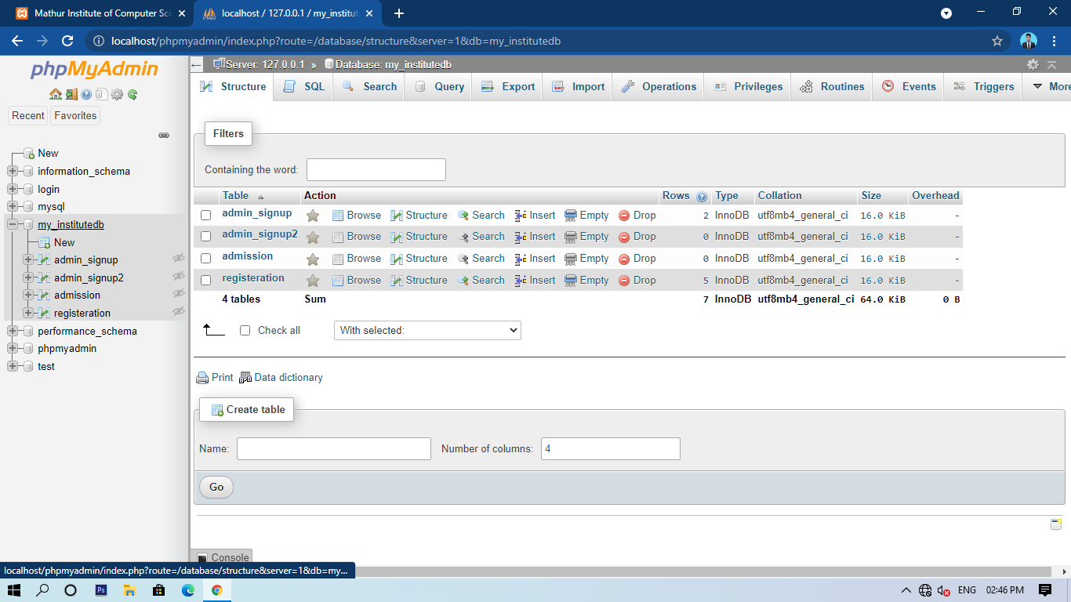

**Admin sign-up Table :**

If any admin user will register itself then their data will be save in this table.

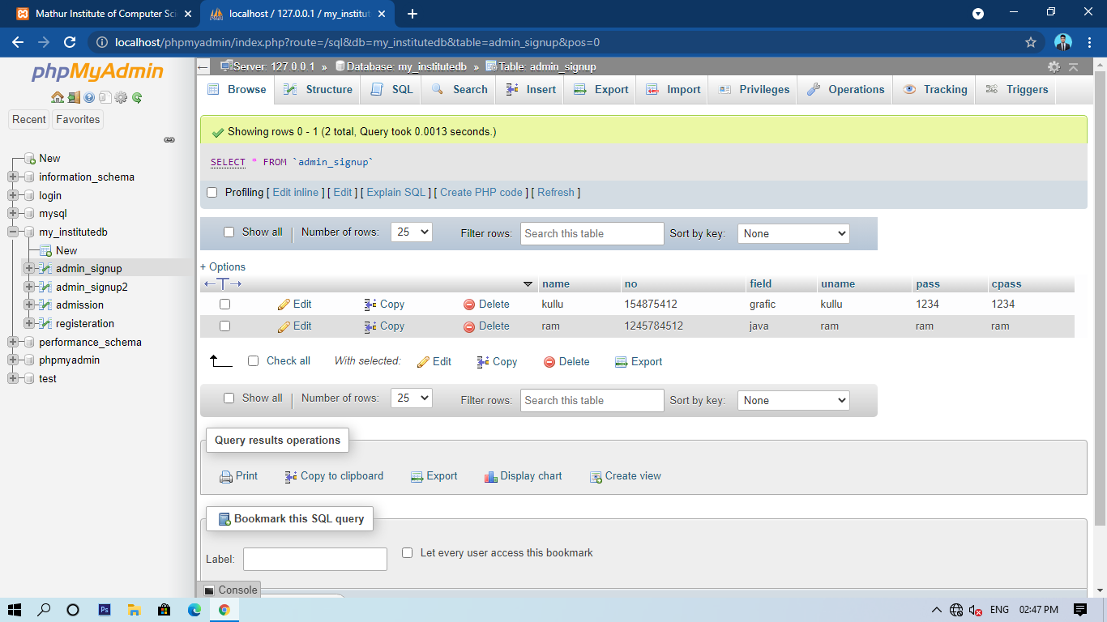

### Student Registration Table:

### If any admin user will register itself then their data will be save in this table.

### 

**Student Admission Table:**

If any student will fill their admission information then their data will be save in this table.

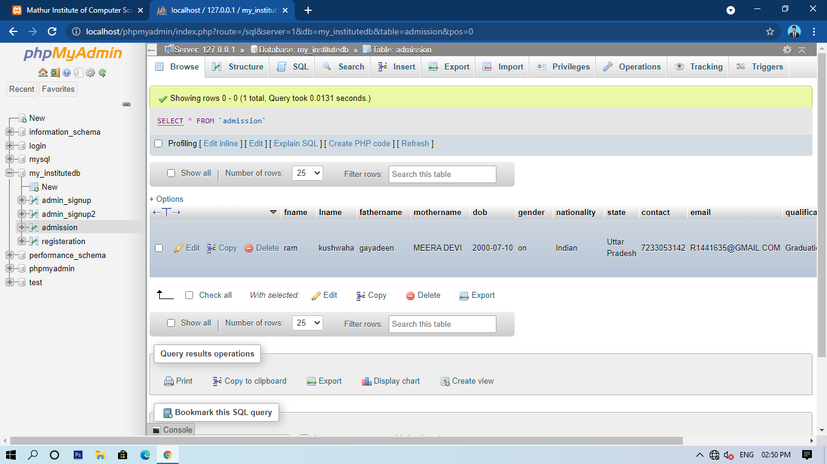

### Use Case name: Student Registration

* **Description:** This use case

describes the scenario where the student registers with the Application by providing all the necessary details, in order to make reservations or managements for Class.

* **Actor:** Student or the Student
* **Input:** The student or the Student will have to provide all the necessary details present in The Student registration form of the application.

### Use Case name: Student Login

* **Description:** This use case describes the scenario where the student logs into the application, with the student name and password • **Actor:** Student or the Student
* **Input:** The student or the Student creates a student name and password He then uses them to logon to the system and make reservations or views any information.

### Use Case name: Book Flights

* **Description:** This use case describes the scenario where the student books Institute Class.
* **Actor:** Student or the user
* **Input:** After logging into the application, the student looks up the information related to various Class and checks the availability of Class. If he finds that there are Any available Class, he then books them.

### Use Case name: Login/Logout

.**Description:** This use case describes the scenario where the

administrator of the application, logs into the system and logs out after the work is done.

**Actor:** Administrator

* **Input:** The administrator logs into the application with the student name and password provided to him.
* **Output:** The application verifies the

authenticity and displays the home page of the administrator.

### Use Case name: Add/Delete or Modify Student information

* **Description:** This use case describes the scenario where the administrator adds, deletes

or modifies Student information in the system database

* **Actor:** Administrator
* **Input:** The administrator of the

applications logs onto the system with his student name and password.

* **Output:** The application authenticates the administrator, and then displays the pa where the administrator can add new Students to the database, or delete existing Students or modify details of Students in the database

### Use Case name: Add/Delete or Modify flight information

* **Description:** This use case describes the scenario where the administrator adds, deletes

or modifies Class information in the application database

* **Actor:** Administrator
* **Input:** The administrator logs onto the system with the student name and password provided to him.
* **Output:** The application authenticates the administrator, by verifying the student name and password. Then the application displays the page where the administrator can add new Class to the database.

## PERFORMANCE REQUIREMENTS

The Institute Management application should be able to respond to the queries submitted by the Student without much delay. When a student searches for a Class, the application should not take much time to return the results.

Considering that the application is of moderate size, it should be able to display the results at a time on a page, when the Student looks up for any particular data.

## ARCHITECTURE DESIGN

### INTRODUCTION

The main purpose of the Architecture Design document is to discuss the architectural design for the Institute Management project in a clear and

concise form. This design document will give a detailed description of the presentation tier, the middle tier which consists of the class diagrams, sequence diagrams for the Institute Management and finally the data tier.

### ARCHITECTURE OF THE AIRLINE RESERVATION SYSTEM

The architecture of the Institute Management is based on the three-tier architecture. This three-tier architecture mainly consists of three layers namely:

* Presentation Tier
* Business Tier
* Data Access Tier

The Presentation Tier converts and displays information into a human legible form. This tier displays information related to services such as browsing the Class availability, management Class etc. It communicates with the other tiers by outputting results to the client tier and all the other tiers.

The Business Logic tier is mainly responsible for information exchange between the student interface and the database of the project. The final layer of the three tiered architecture is the Data Access tier, which mainly consists of the Database servers. The information related to the Institute Management is stored and retrieved from here.

A simple representation of the three-tier architecture would be as follows:

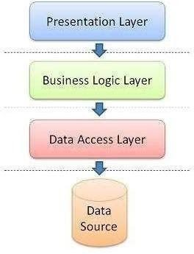

### PRESENTATION TIER

The presentation tier is the top most layer of the Institute Management application.

The presentation tier is mainly responsible for the student interface of the application which deals with the presentation of data to the student. The presentation tier of the Institute Management is mainly formed by the

C#.NET forms. In the case of the Institute Management project, I have used the Visual Studio 2012.NET to create the forms. Each form will have the extension .cs and there are several forms created for the student and the administrator.

### BUSINESS LOGIC TIER

The Business Logic Tier is the middle tier of the three-tier architecture. The business logic for the Institute Management would be present here. In the case of my project, the C# classes would be performing the duty of the business logic. This is the layer which is responsible for the information exchange

between the student interface and the database. The Institute Management mainly consists of the Students, which can be further classified into the student and administrator of the Institute Management

### SEQUENCE DIAGRAM

The sequence diagram for the Student of the Institute Management would be as follows:

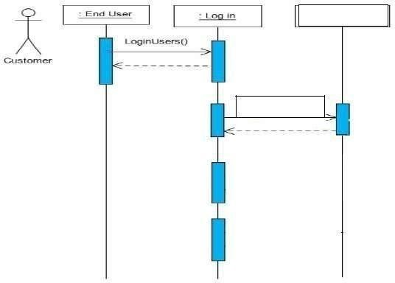

### DATABASE TIER

The database tier is the final and last tier of the three-tier architecture. All the data related to the Airline Reservation System project is stored and

retrieved from here. For this project I have used the Microsoft SQL server to create the database. To be specific, Microsoft SQL server 2012 is being used. It is very easy to work with and makes creation and maintaining of tables very easy.

## COMPONENT DESIGN

The attributes of this table are Student id which is a reference key, Class NO, serviced which is also a reference key, date of service.

## TEST PLAN

**TEST PLAN IDENTIFIER**

**Institute Management Site**

### INTRODUCTION

The main purpose of the test plan for the Institute Management

System is to discuss the testing details of the use cases of the Institute Management Site. The software project test plan also describes the objective, scope and approach of the software testing effort for the Institute Management Site project. The test plan for the Institute Management Site also indicates the personnel responsible for each task and also specifies the risks associated with the test plan.

### OBJECTIVES

The main objectives of the test plan for the Institute Management Site are as follows:

* To identify the features of the system that will be tested.
* To identify and define all the activities necessary to prepare for and conduct the testing process on the Institute Management Site.
* To discuss the testing techniques being used to test the Institute Management Site.

### DEFINITIONS

The following are some of the terms and definitions that are related to the test plan of the

Institute Management Site:

* **Pass/Fail criteria:** Decision rules that are used to determine whether a software item passes or fails a test.
* **Test:** A collection of one or more test cases
* **Test Item:** A software item that is an objective of testing.
* **Test Plan:** A document describing the scope,

approach, resources and schedule of the intended testing activities.

* **Test Summary Report:** A document summarizing the testing activities and results.
* **Testing:** The process of analyzing a software item to detect the differences between the existing and required conditions.

#### TEST ITEMS

This section of the test plan lists all the items of the Institute Management Site project that will be tested:

* Login
* generate bill
* Register

#### APPROACH

This section of the test plan describes the overall approach for testing the Institute Management Site project. The approach followed for testing the

Institute Management Site ensures that the major features of the project are adequately tested. The testing would be carried out on the Institute Management Site while logging into the system as a Institutemanager or a super admin of the system.

### INTEGRATION TESTING

In Integration Testing, the individual software modules are

combined and tested as a whole unit. The integration testing generally follows unit testing where each module is tested as a separate unit. The main purpose of the integration testing is to test the functional and performance requirements on the major items of the project.

All the modules of the project developed individually would be combined together and tested as a whole system in the integration testing

### REGRESSION TESTING

The Regression Testing is generally done whenever modifications are made to the source code of a project. The Regression Testing can also be defined as the process of testing changes made to the computer program and also makes sure that the older programming still works with the new changes.

So, before any new version of a software product is released, the old test cases for the project will be run against the software with the changes made, to make sure that the old functionalities of the project still work.

### ACCEPTANCE TESTING

This testing is generally performed when the project is nearing its end. This test mainly qualifies the project and decides if it will be accepted by the students of the system.

The students or the Students of the project are responsible for the test.

### SYSTEM TESTING

The system testing is mainly done on the whole integrated system to make sure that the project that has been developed meets all the requirements. The test cases for the system testing will be the combination of unit and integration tests

**TEST CASES**

The following are the test cases for the Institute Management Site:

### TEST CASE 1 – STUDENT LOGIN

* **Incorrect Input:** Incorrect student name.
* **Pass Criteria:** An appropriate message should be generated to indicate that an invalid student name has been typed.
* **Correct Input:** The correct input would be a valid student name of the student and a correct password associated with the student id which he uses to log in.

### TEST CASE 2 – STUDENT REGISTRATION

* **Incorrect Input:** Wrong format entered in the input fields for the registration page.
* **Pass Criteria:** An appropriate message should be generated to the student saying that he has entered the wrong format in the specific input field.
* **Correct Input:** The correct input would be a correct format entered by the student into the input fields of the registration page.
* **Pass Criteria:** The pass criteria for Institute Management Site.

### TEST CASE 3 – STUDENT REGISTRATION

* **Incorrect Input:** The data fields left out empty in the registration page.
* **Pass Criteria:** An error message should be generated to

the student saying that he has to fill out those fields in order to be registered into the system.

* **Correct Input:** The correct input in this case, would be that the Student would enter the data in all the fields in the registration form.
* **Pass Criteria:** The pass criteria for the system would be that it accepts all the new student details and then registers the student

and helps him log into the system.

### TEST CASE 4 – GENERATE BILL

● **Incorrect Input:** Incorrect input in this case, would be incorrect search criteria entered or incorrect format of data entered into the data entry fields of the generate bill page.

* **Pass criteria:** A message has to be

generated to the student indicating the wrong entry that he has made in the fields.

* **Correct Input:** A correct input would be entering the data into the data entry fields in a correct format.
* **Pass Criteria:** The pass criteria for this test case would be that data will be added to the database. and bill will be generated

### PASS OR FAIL CRITERIA

The test cases executed on the Institute Management Site will pass if they meet the specific requirements mentioned in the Vision document of the project. A test case is said to fail, if the desired functionality is not satisfied by the system.

**SUSPENSION CRITERIA AND RESUMPTION REQUIREMENTS**

### SUSPENSION CRITERIA

Testing for all the dependent features will be suspended if a test case fails. The failed test case will be logged onto the test log which contains the description for the error.

### RESUMPTION REQUIREMENT

The test cases which are not dependent on the case where the bug is reported will be executed in parallel with the bug fixing. Once the failed test case has been taken note of and has been identified and fixed then the testing for the failed test case will resume.

### TEST DELIVERABLES

The following documents will be produced after the testing phase for the Institute Management Site has been completed.

* Test Plan
* Test Cases
* Test Log

**ASSESSMENT EVALUATION**

#### INTRODUCTION

The Assessment Evaluation document presents the results obtained by testing the Institute Management Site. The test cases are in reference to the test cases defined in the Test Plan document from the Phase II.

### TEST CASE RESULT SUMMARY

The summary of the test case result has been depicted in the table shown below:

These are the test cases for the Student/Student pages. The major part of testing has been concentrated on the student pages, as they would be the main clients of the Institute Management Site.

#### DETAILED TEST RESULTS MANUAL TESTING

To start with, I have performed manual testing on the Institute Management Site Manual Testing is one of the oldest and rigorous methods of software testing. This testing strategy gives the best opportunity to check every page thoroughly and make sure it works in the expected manner. Due to the complexity of the various automation tools and the time available for testing the entire application, I preferred to use manual testing based on the fact that it is one of the best methods of testing suggested for a beginner. All the test cases mentioned in the Test Plan document of Phase II were tested here.

1. Application and scope

6.1 Applications & Scope

In this step, we provide a detailed description about the existing system and the problems faced in the existing system. This stage there is no existing system previously; we are developing a new system. Till now no system is available with this type of features and facilities. This system is developed for the all types of students with highly flexible and configurable product is envisaged to ensure global marketing

1.2.2 Proposed System Features:

Some of the service providers won't allow you to choose your Institute, they only allow you to select location and quality of the Institute. Considerable discounts on Institutes may be available in off- seasons.

Utilize the service of online Institute management service providers when you are planning for a trip.

Each and every Student looks to book their Institute Class early and conveniently.

Students can Post, update and delete the links in all categories.

Online Institute management is the best way to book Class in your favourite Institutes.

Planning a vacation has never been easier and more reasonable than now. Easiness, affordable pricing, and simple comparison shopping make online Institute managements accepted to all.

## 6 Getting Started

### ✔ Install / Uninstall Infinity Universe Android/iOS

**Application: Steps to Install:**

Go to start button, and type **Xampp Server t**o open it.

This will open **Xampp Server- Control Panel**. After opening it, just click **Start** on **Apache**to start the server:

Now, go to the Web Browser and type, **localhost/My_instititue** and press enter.

On pressing enter, you can see the following, locate your PHP file **index.php** and click on it

Just press enter in the address bar, and you can see the output of your first PHP program

**Or**

To access our project service anyone can directly visit to

<https://mics.infinityfreeapp.com/>

**Steps to Uninstall:**

1. Close the Browser.

## 7. Future Enhancement

Will be adding and enhancing this project in future with trends and services.

And many more module will be add like attendance, fees, examination etc.

## 8. Conclusion

This project is designed to meet the requirements of the Online Institute Management Site. It has been developed using Web Technologies keeping in mind the specifications of the system.

For designing the system, we have used simple Data Flow Diagrams. Overall, the project teaches us the essential skills like:

▪ Using system analysis and design techniques like data Flow Diagram in designing the system.

**▪** Understanding the database handling and query processing.

## 11. References

1. https://www.javatpoint.com/
2. https://www.w3schools.com/
3. Google
4. YouTube
5. Certification Training & Internship.